Available in sizes 1.5", 2", 3", 4", 6", 8", 10", and 12"

Octave brings the latest in ultrasonic metering technology to Commercial/Industrial (C&I) water meters and puts precise measurement where the real flows exist. An excellent alternative to mechanical compound, single-jet, floating ball, fire-service type and turbine meters, Octave excels at maintaining sustained accuracy for the life of the meter while providing smart AMR capabilities.

CTAV E ® ULTR A SONIC ME TER
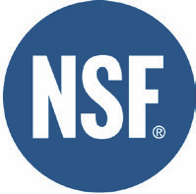

Technical Specifications:

Working Pressure - 175 PSI

Liquid Temperature - 33° - 122 °F

Metrological Characteristics - Meets ANSI/AWWA Standards C715-
18, C750-19, ISO 4064 rev. 2014

Configuration - Compact-Display built into unit

Power Source - 2 x D Size Lithium Thionyl Chloride batteries - 10
year warranted life time

Environmental Protection - NEMA 6P+ (IP68+), Ambient operation
temp. -13 °F / +131 °F for the display

Display Units - Multi line 12 digit LCD (Programmable USG, Cubic Feet, Cubic Meters, Acre Feet for volume and GPM, Lt/s, or M³/h for rate of flow)

Output - Programmable Encoder, Pulse, 4-20, or Modbus; Optional
dual output available in encoder + pulse
Features & Benefits:

• Grade 316 Stainless Steel (2"-8") or Epoxy Coated
Ductile Iron (10"-12") body design provides full
compliance with ANSI/NSF 372 (AB1953 or NSF61G).

• No moving parts. Minimal flow intrusion. Enduring
accuracy.

• Easy to install Floating Flanges on 2"-8" and Integrated
Flanges on 10"-12".

• No required strainer.

• Wide beam ultrasonic measurement sensors for high
accuracy and reliable operation.

• Industry standard communication protocol for
integration with most third-party AMR/AMI systems.

• Active leak, burst, reverse flow, empty pipe,
measurement failure, and low battery. LCD also displays
rate of flow and water temperature.

• Ruggedized NEMA 6P/IP-68+ construction; fully
submersible design.

• Designed to meet standards for both North American
and International C&I water meters.

• Optional flow measurements; Forward Only, Net
Volume or Alternating Display (Forward and Reverse
Consumption displayed separately).

Performance Data & Dimensions

Octave Operating Characteristics and Dimensions

Safe Maximum Operating Capacity

Normal Operating Range (98.5% - 101.5% Accuracy) * Extended Low Flow(97% - 103% Accuracy)
Length Width Height
Height from Center Pipe

Weight
1.5"x13" 2"x10" 2"x15.25" 2"x17" (40 mm) (50 mm) (50 mm) (50 mm)
250 GPM 250 GPM 250 GPM 250 GPM (57 m 3/h) (57 m 3/h) (57 m 3/h) (57 m 3/h)
0.50 – 250 GPM 0.50 – 250 GPM 0.50 – 250 GPM 0.50 – 250 GPM (0.11 – 57 m 3/h) (0.11 – 57 m 3/h) (0.11 – 57 m 3/h) (0.11 – 57 m 3/h)
0.25 GPM 0.25 GPM 0.25 GPM 0.25 GPM (0.06 m 3/h) (0.06 m 3/h) (0.06 m 3/h) (0.06 m 3/h)
13" 10" 15.25" 17" (330 mm) (250 mm) (390 mm) (432 mm)
5-3/4" 5-3/4" 5-3/4" 5-3/4" (146 mm) (146 mm) (146 mm) (146 mm)
6-3/4" 6-3/4" 6-3/4" 6-3/4" (172 mm) (172 mm) (172 mm) (172 mm)
2-1/8" 2-1/8" 2-1/8" 2-1/8" (54 mm) (54 mm) (54 mm) (54 mm)
20 lbs 15 lbs 22 lbs 24 lbs
(9 kg) (7 kg) (10 kg) (11 kg)

* In the water temperature of 45° to 85° F (7° to 30° C), meter consumption is accurately measured at:
• +/- 1.5% in the Normal Operating Range
• +/- 5% in the Extended Low Flow

Octave Operating Characteristics and Dimensions

Safe Maximum Operating Capacity

Normal Operating Range (98.5% - 101.5% Accuracy) * Extended Low Flow(97% - 103% Accuracy)
Length Width Height
Height from Center Pipe

Weight
3" 4" 6" 8" 10" 12"
(80 mm) (100 mm) (150 mm) (200 mm) (250 mm) (300 mm)
500 GPM 1,000 GPM 1,600 GPM 2,800 GPM 5,500 GPM 5,500 GPM (114 m 3/h) (227 m 3/h) (363 m 3/h) (636 m 3/h) (1,250 m 3/h) (1,250 m 3/h)
1 – 500 GPM 1.5 – 1,000 GPM 3 – 1,600 GPM 5 – 2,800 GPM 14 – 5,500 GPM 14 – 5,500 GPM (0.23 – 114 m3/h) (0.34 – 227 m 3/h) (0.68 – 363 m 3/h) (1.5 – 636 m 3/h) (3.2 – 1,250 m 3/h) (3.2 – 1,250 m 3/h)
0.5 GPM 0.75 GPM 2 GPM 4 GPM 8 GPM 8 GPM (0.11 m 3/h) (0.17 m 3/h) (0.45 m 3/h) (0.9 m3/h) (1.8 m3/h) (1.8 m3/h)
12" 14" 18" 20" 17-3/4" 19-3/4" (305 mm) (356 mm) (457 mm) (508 mm) (451 mm) (502 mm)
7-1/2" 9" 11" 13-1/2" 16" 19-3/4" (190 mm) (229 mm) (280 mm) (343 mm) (406 mm) (502 mm)
8-1/2" 9-7/8" 10-7/8" 12-7/8" 16-1/2" 19-3/4" (216 mm) (250 mm) (276 mm) (327 mm) (419 mm) (502 mm)
3-1/2" 4-1/2" 5-1/8" 6-3/8" 8" 9-7/8" (90 mm) (115 mm) (130 mm) (162 mm) (203 mm) (251 mm)
23 lbs 35 lbs 51 lbs 78 lbs 150 lbs 210 lbs
(10.5 kg) (16 kg) (23 kg) (35 kg) (68 kg) (96 kg)

* In the water temperature of 45° to 85° F (7° to 30° C), meter consumption is accurately measured at:
• +/- 1.5% in the Normal Operating Range
• +/- 5% in the Extended Low Flow

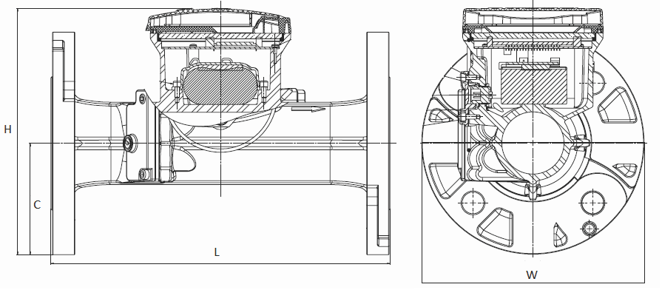

NOTE — For Performance charts please see Engineering Document - Octave | Version 10.17

v0409.20F

